1. 关于Association Negotiation：

Assocation需要用到的三个关键参数（Application Context, Presentation Context,User Information Items）

Association establishment is used to negotiate the type of data to be exchanged and how the data will be encoded. DICOM AEs establish Associations by using the ACSE A-ASSOCIATE Service as defined by Part 8 of the DICOM Standard. Three key parameters conveyed in the A-ASSOCIATE Service are the Application Context, Presentation Context, and the User Information Items.

Note：

Readers should remember that only one A-ASSOCIATE request is offered for each Association and it contains all of the negotiation parameters.

1. Application Context：

dcm4che的CS说是The specification of the type of communication used between Application Entities. Example:DICOM network protocol.

Application Context的定义：

In the DICOM standard, application context is defined as "the set of application service elements, related options, and any other information necessary for the interworking of Application Entities on an Association; in particular [the application context] specifies the DIMSE Protocol used by the application layer"

In practice, the application context negotiated between DICOM AEs is always DICOM 3.0 (1.2.840.10008.3.1.1.1). The application context is always specified as one of the parameters during negotiation of a DICOM association, and must be specified in a device's DICOM conformance statement.

If there ever is going to be a DICOM 4.0, this is likely to be updated.

An Application Context explicitly defines the set of application service elements, related options and any other information necessary for the inter working of Application Entities on an Association; in particular, it specifies the DIMSE Protocol used by the Application Layer.

下面说了两个AE间如何就Application Context进行协商的：

Two Application Entities establish an Association by agreeing on an Application Context. The requester of an Association proposes an Application Context Name and the acceptor returns either the same or a different Application Context Name. The returned name specifies the Application Context to be used for this Association. The offer of an alternate Application Context by the acceptor provides a mechanism for limited negotiation. If the requester cannot operate in the acceptor's Application Context, it shall issue an A-Abort request primitive. Such a negotiation will facilitate the introduction of new versions of the DICOM Message Exchange Protocol in the future.

1. Presentation Context：

A Presentation Context defines the presentation of the data on an Association. It provides a lower level of negotiation and one or more Presentation Contexts can be offered and accepted per Association.

A Presentation Context consists of three components, a Presentation Context ID, an Abstract Syntax Name, and a list of one or more Transfer Syntax Names.

Only one Abstract Syntax shall be offered per Presentation Context. However, multiple Transfer Syntaxes may be offered per Presentation Context, but only one shall be accepted.

For each SOP Class or Meta SOP Class a Presentation Context must be negotiated such that this Presentation Context supports the associated Abstract Syntax and a suitable Transfer Syntax. Presentation Contexts will be identified within the scope of a specific Association by a Presentation Context ID.

一些关于Presentation Context的规则：

a. the Association-requester may offer multiple Presentation Contexts per Association.

b. each Presentation Context supports one Abstract Syntax (related to a SOP Class or Meta SOP Class) and one or more Transfer

Syntaxes.

c. the Association-acceptor may accept or reject each Presentation Context individually.

d. the Association-acceptor selects a suitable Transfer Syntax for each Presentation Context accepted.

Presentation Context主要有三个组成部分：Presentation Context ID，Abstract Syntax和一系列Transfer Syntax。

其中每个Presentation Context只能提供一个Abstract Syntax，而Transfer Syntax可以提供多个，但最终只有一个会被接受。

Presentation Context ID就是该Presentation Context的一个标识，其中一次Assocation可以有多个Presentation Context，如：

对于一次Assocaition不同的Presentation Context，需要独自的接受或拒绝。

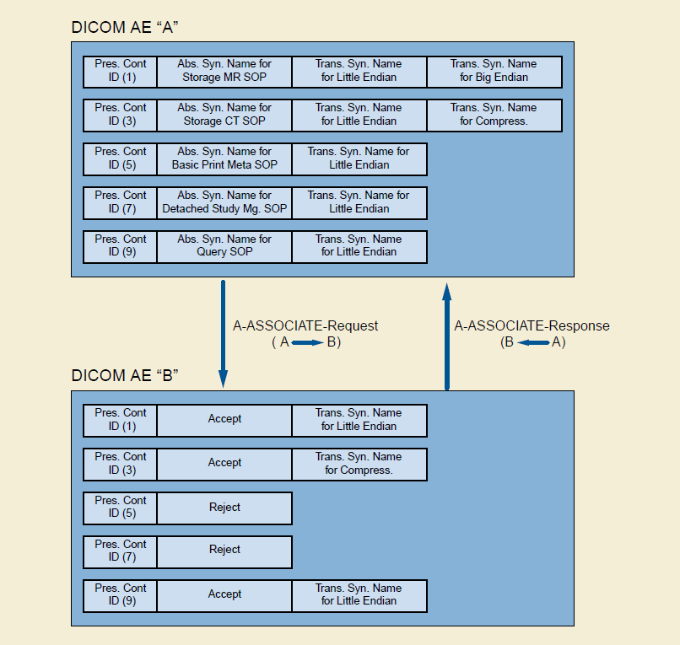

Abstract Syntax的作用：

Abstract Syntaxes specify the Application Layer Data Elements and Application Layer protocol control information (with associated semantics) that are independent of the encoding technique used to represent them.

Abstract Syntax的内容：

Each Abstract Syntax shall be identified by an Abstract Syntax Name in the form of a UID. DICOM AEs use the Abstract Syntax Name to identify and negotiate which SOP Classes and related options are supported on a specific Association. Abstract Syntax Names shall be defined in the Service Class Definitions specified in PS3.4. Each Abstract Syntax Name defined shall have a value of either

• a Service-Object Pair Class UID

• a Meta Service-Object Pair Group UID

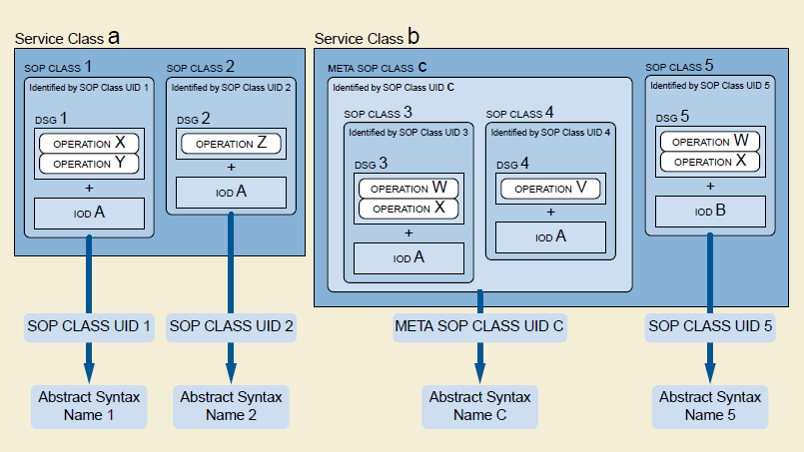

1. User Information Items：

Peer DICOM AEs negotiate, at Association establishment, a number of features related to the DIMSE protocol by using the ACSE User Information Item of the A-ASSOCIATE request.

就是除了上面两个信息外还有一些附加信息，主要是协商关于连接的参数等。

其中包含：

(1)Maximum Length Application PDU Notification：

跟对方说自身在本次连接中最大能接收多大的PDU包。

(2)Implementation Identification Notification

The implementation identification notification allows implementations of communicating AEs to identify each other at Association establishment time. It is intended to provide respective (each network node knows the other's implementation identity) and non-ambiguous identification in the event of communication problems encountered between two nodes.

需要提供Implementation Identification UID，而Version是可选的。

这个UID主要是声明了自身implementation的类别。

(3)Asynchronous Operations (And Sub-Operations) Window Negotiation（可选）

The Asynchronous Operations Window is used to negotiate the maximum number of outstanding operation or sub-operation requests (i.e., command requests) for each direction.

默认是Synchronous

(4)SCP/SCU Role Selection Negotiation（可选）

用于确定AE节点谁是SCU，谁是SCP，默认请求者是SCU，接收者是SCP。

(5)Service-Object Pair (SOP) Class Extended Negotiation（可选）

这个信息的格式以及neogiation的方式是由Service Class确定的。

(6)Service-Object Pair (SOP) Class Common Extended Negotiation（可选）

跟上面不同的是该信息不是由某个专门的Service Class定的。

会包含以下信息：

The information included for each SOP Class for which a sub-item is present consists of a Service Class UID and (optionally) a Related General SOP Class UID.

(7)User Identity Negotiation（可选）

就是让接收方知道请求方的User信息。这个会涉及到安全认证方面。接收方根据此信息可以返回认证失败。

Negotiation，如下是一次PACS的Association Response：

https://stackoverflow.com/questions/42977712/dicom-is-this-a-valid-associate-response

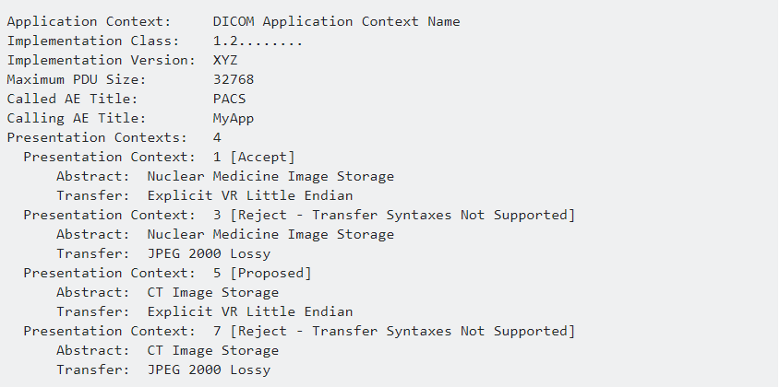

个人理解：

1. Application Context是确定通信方式，如通信协议，通信协议版本。
2. Negotiation会用到Abstract Syntax，这个会有一个UID，对应一个SOPClassUID或者MetaSOPClassUID，其中前只包含一个SOP Class，后者包含多个SOP Class。
3. Transfer Syntaxes是说到数据是怎样被编码的，会被用到Negotiation。
4. 用于Negotiation主要是三个重要参数：Application Context, Presentation Context, and the User Information Items这些信息通常都会一次性提供。
5. 接收方拒绝连接的原因可以是多种，如SOPClass不支持，Transfer Syntaxes不支持，认证失败等。
6. 虽然说dcm文件都有像SOPClassUID，TransferSyntaxUID这样的信息，但Negotiation的时候文件还是没有开始传输的，因此建立连接还没有正式开始服务的时候，是不会传输服务数据信息的。

遗留问题：

1.

需要研究SOP类的具体作用。

2.

需要清楚在Negotiation成功之后，比如说对于Store操作会传输什么数据，是直接把dcm文件传过去还是什么？

1. 关于SOP究竟是用来干什么的？

关于SOP Class的作用：

The SOP Class definitions in PS3.4 contain the rules and semantics that may restrict the use of the services in the DIMSE Service Group and/or the Attributes of the IOD. PS3.10 and PS3.18 contain the rules and semantics that may restrict the attributes of the IOD or the use of the services in the Media Storage Services and the Web Services respectively.

The selection of SOP Classes is used by Application Entities to establish an agreed set of capabilities to support their interaction for SOP Classes based on DIMSE Services. This negotiation is performed at association establishment time as described in PS3.7. An extended negotiation allows Application Entities to further agree on specific options within a SOP Class.

The SOP Class as defined in the DICOM Information Model is equivalent in ISO/OSI terminology to the Managed Object Class. Readers familiar with object-oriented terminology will recognize the SOP Class operations (and notifications) as comprising the methods of an object class.

关于Service Class的作用：

A Service Class Specification defines a group of one or more SOP Classes related to a specific function that is to be accomplished by communicating Application Entities. A Service Class Specification also defines rules that allow implementations to state some pre- defined level of conformance to one or more SOP Classes. Applications may conform to network SOP Classes as either a Service Class User (SCU) or Service Class Provider (SCP), and to media exchange SOP Classes as a File Set Creator (FSC), File Set Reader (FSR), or File Set Updater (FSU).

Service Class有哪些？

Verification Service Class

Query/Retrieve Service Class

Study Content Notification Service Class

Patient Management Service Class

Procedure Step SOP Classes

Results Management Service Class

Print Management Service Class

Media Storage Service Class

Storage Commitment Service Class

Basic Worklist Management Service

Queue Management Service Class

Application Event Logging Service Class

Relevant Patient Information Query Service Class

Instance Availability Notification Service Class

等等

不同的Service Class有不同的功能，比如Verification Service Class是测试AE之间在应用层层面的连通性的，Storage Service Class是AE之间传输IOD数据的，不同的Service Class会用到不同的方法和IOD，它规定了SCU和SCP各自都要实现相应的功能，SCU和SCP在当中充当角色是有一定要求的，则不同的Service Class SCU和SCP对于其都会产生不同的行为，之间的交流会具有一定的规范。

个人理解：

1.

对于不同的SOPClass Neogitiation Association的步骤是大致相同的，但有些是可以包含附加选项用于Negotiation，比如说Storage Service Class可以用Service-Object Pair (SOP) Class Extended Negotiation和Service-Object Pair (SOP) Class Common Extended Negotiation，比如说会传输这种信息：

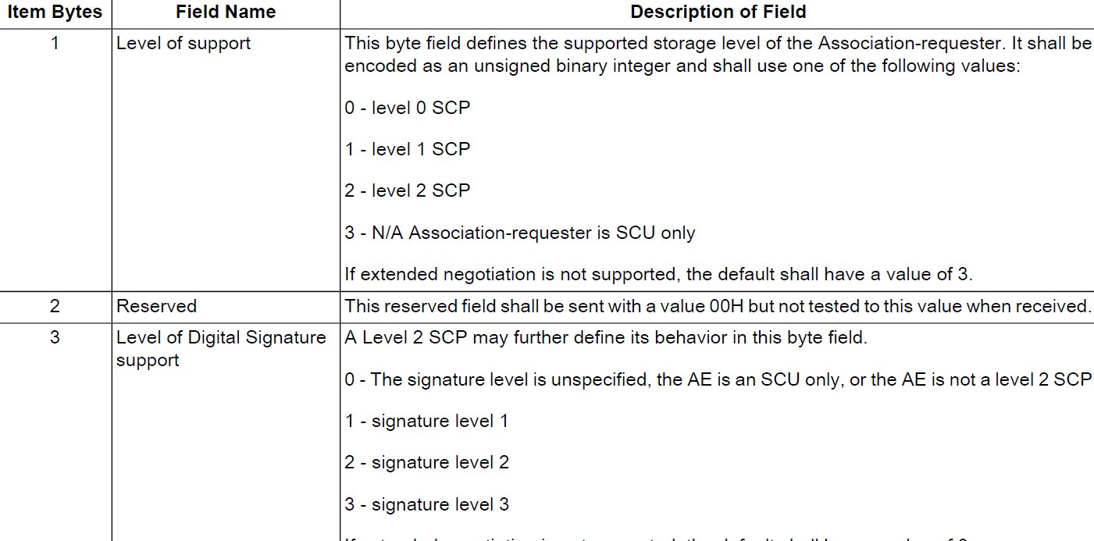

比如说Storage Level这一项，不同的Level会根据IOD不同类型的Attributes进行储存，有些Attributes在储存时可能是会被丢弃的，其中SCP可以选择是否对IOD的Attribute进行检验。

2.

SCP可能是会把一些Attribute进行修改的。

3.

不同的Service Class有不同的功能，比如Verification Service Class是测试AE之间在应用层层面的连通性的，Storage Service Class是AE之间传输IOD数据的，不同的Service Class会用到不同的方法和IOD，它规定了SCU和SCP各自都要实现相应的功能，SCU和SCP在当中充当角色是有一定要求的，则不同的Service Class SCU和SCP对于其都会产生不同的行为，之间的交流会具有一定的规范。

4.

SOP的底层会调用DIMSE。

遗留问题：

1.

对于SOP需要深入理解，特别是对于Service-Object Pair (SOP) Class Extended Negotiation，Service-Object Pair (SOP) Class Common Extended Negotiation，这两个选择项是干什么的？

2.

对于某些SOP类，比如Basic Text SR Storage，具体要复合的规范究竟是什么，在哪里可以查到？